## **LED Display Rendering & Zone Configuration proposal – Software Tool Development Document** Software Tool

The tool runs on PC. It is used to configure the LED font including bitmaps, icons and zones. It utilizes the icons, fonts that are stored in the PC. The generated file will be a C-Array file(binary).

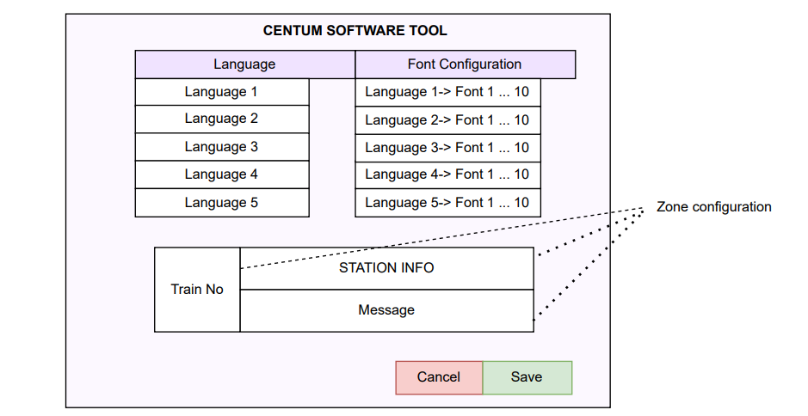

The C array file will be an input for the font handling in the rendering engine.

It will support up to 10 configurations of each of the mentioned languages.

* English, Hindi, Marathi, Kannada, Malayalam, Tamil, Telugu, Gujarati, Punjabi, Bengali, Oriya and Urdu.
* LED display can be configured to support up to 5 languages, it’s based on the memory constraint of the NXP controller.

**Step-wise Activities for python code to run and generate .c file**

Step-by-step prerequisites to run the provided Python GUI code for TTF to C array conversion:

1. **Install Python 3.x**
   * Download and install Python 3.x from the official website.
   * Verify installation by running python --version in a terminal or command prompt.
2. **Set up Python Project (e.g., PyCharm)**
   * Create a new Python project.
   * Configure project interpreter to Python 3.x.
3. **Install Required Libraries**
   * Open a terminal or PyCharm terminal.
   * Install Pillow:

text

pip install pillow

* + Ensure Tkinter is available:
    - Tkinter is included by default in most Python installations.
    - On some Linux systems, you may need to install it separately, e.g.:

text

sudo apt-get install python3-tk

1. **Prepare Font File**
   * Have a TrueType font file (.ttf) accessible on your system.
   * This file will be selected later via the GUI.
2. **Run the Python Script**
   * Run the script containing the provided code.
   * A GUI window opens for selecting the TTF file.
   * After selection, click the button to generate the C array file.
3. **Check Output**
   * The generated C file named font_data.c will be saved in the same directory.
   * Verify that the file contains the expected C array data.

This ensures the environment and necessities for executing the font converter GUI application are met.  
  
  
Python code